**UNIVERSITY ADMIT ELIGIBILITY PREDICTOR**

**Anaconda Installation**

**Team ID:** PNT2022TMID34608

**Project title:** University Admit Eligibility Predictor

**Step 1:** Download and Anaconda

Step 2: Install the Anaconda

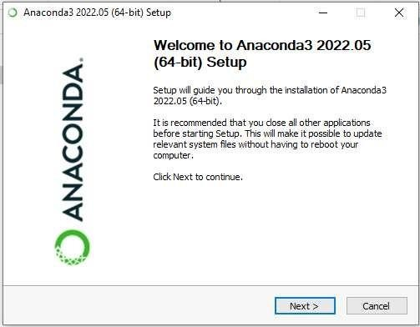

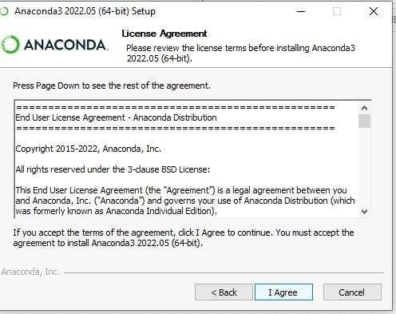STEP 3: Click I Agree

STEP 4: Choose the Location

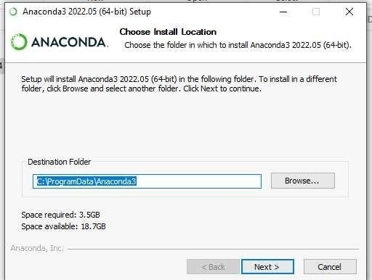

STEP 5: Installing the Requiring packages

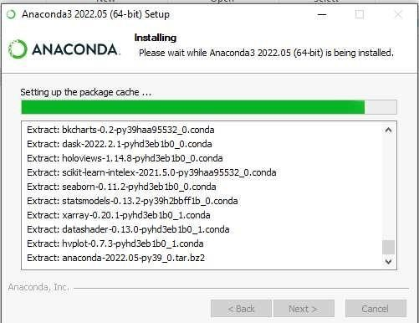

STEP 6: Setting up the base environment

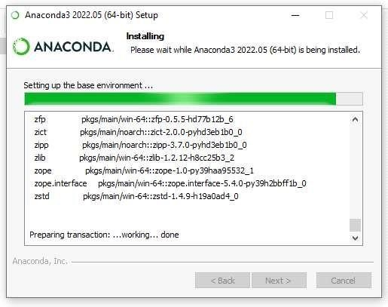

STEP 7: Successfully Installed .

